Gatditaliitrz id ujyit
Gatditaliitrz id ujyit

The Grammar of Zayit (cover). Title in both affel (Gsheedinlajud efsheedm juyit) and zayit.

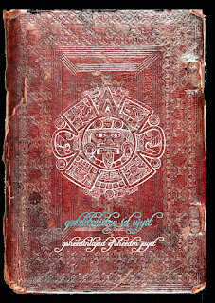

by Ayndryl on Thursday, November 05, 2009
Labels Affel's language , Ladd cryptolect

